This template is to demonstrate the capability to integrate an image coming from CDS into MS Word

First step is to ensure you have enabled the Developer tab in Word. To do so, right click in the ribbon, then Customize the Ribbon, check the Developer tab, then OK.

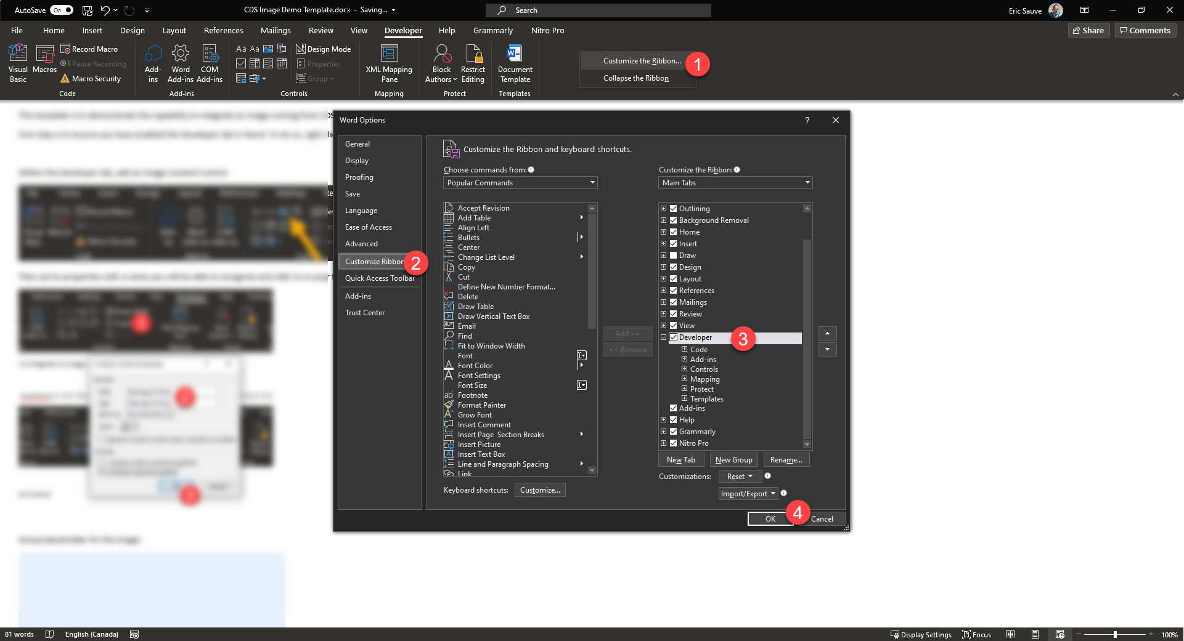

Within the Developer tab, add an Image Content Control

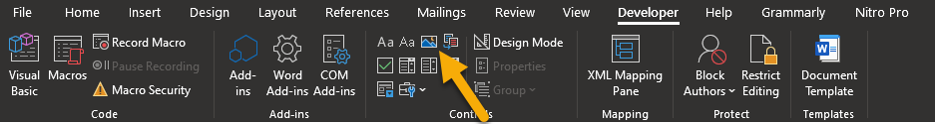

Then set its properties with a name you will be able to recognize and refer to in your flow:

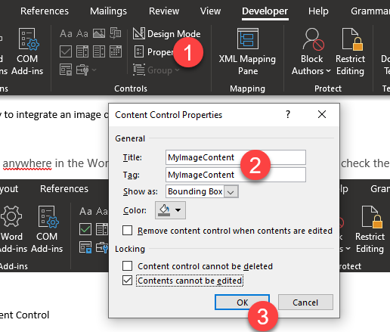

Actual placeholder for the image:

